**Creating visualizations in Tableau**

A diverging color palette in Tableau displays characteristics of values using what color combination?

Intensity for the range and hue for the magnitude

**Intensity for the magnitude and hue for the range**

Hue for the range and tint for the margin of error

Shade for the accuracy and grayscale for the reliability

**Correct**

A diverging color palette in Tableau displays a value’s magnitude by color intensity and a value’s range by color hue.

### 2.Question 2

A data analyst creates a Tableau visualization to compare the trade (amount of goods and services exchanged) between the European Union (EU) and Australia. Which color choice could be misleading?

Blue for the EU and gray for Australia

Orange for the EU and brown for Australia

Beige for the EU and purple for Australia

**Green for the EU and red for Australia**

**Correct**

A lot of people associate green with positive results and red with negative results. Green could falsely represent a trade surplus for the EU and red could falsely represent a trade deficit for Australia.

### 3.Question 3

How could you adjust the labels to make the following visualization more effective? Select all that apply.

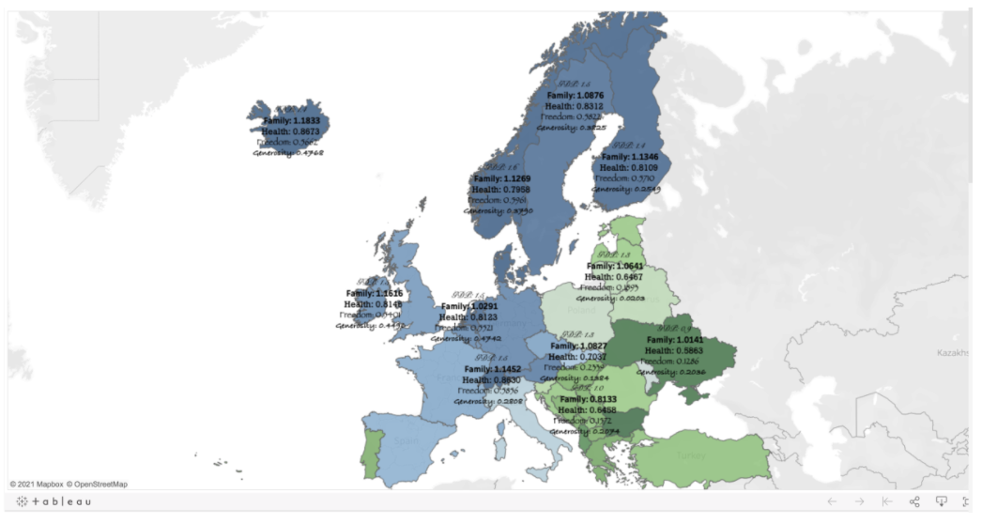

Each country has statistics for family, health, freedom, and generosity

Use a single font for the labels

Change the font color for the labels from black to white

**Reduce the number of labels**